

David Haye, World Heavyweight Boxing Champion, chooses Equmen for pre-fight training

In a match reminiscent of David and Goliath, UK superstar David Haye put on a magnificent performance on November 7th to claim the WBA Heavyweight title from 7 ft tall, 23 stone Russian Nikolay Valuev in Numremberg. What did he train in the week before? The Equmen Core Precision Undershirt.

Recommended by his physiotherapist, the Equmen shirt has proved to be the ultimate support garment for David’s training. “Core stability and support are extremely important in boxing,” says David Haye, “Equmen provides the extra solidarity I need during training and helps prevent injury.”

Equmen’s high-performance Core Precision Undershirt is a compression product designed to improve the bio-mechanics of the wearer by reinforcing the body’s natural structure from the core. Combining physiotherapy taping techniques with seamless, body-response fabrics the garment fits like a second skin to improve posture, provide core support, reduce the risk of injury and speed muscle recovery, thereby improving total sport performance.

Lending credence to the physiological benefits, leading physiotherapist Kevin Lidlow from The Third Space in London has analyzed the garment and claims, “It definitely helps with postural support by encouraging optimal horizontal extension and retraction of the upper central key points, thereby giving a neutral posture. The wearer should be aware of less effort and stress, particularly with prolonged standing or sitting. This is great for any athlete.”

Athletes like David Haye choose Equmen for the ultimate in comfortable, stabilising support garments. Equmen proudly supports athletes all over the world.

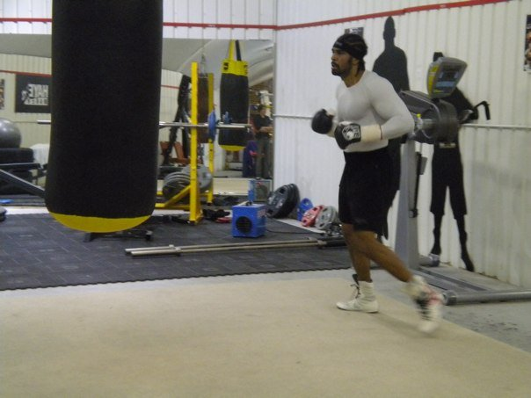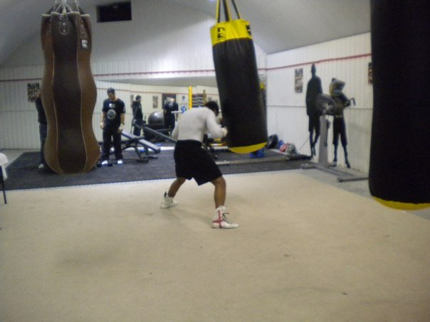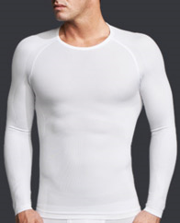

About Equmen
- Equmen is a Sydney-based company specialising in high-performance compression undergarments that leverage sport technology and physiological insights to benefit men from street to sport.
- Equmen stormed the market in 2009 with its Core Precision Undershirt, which has since received accolades from publications including Time Magazine, Men’s Health, GQ, Sports Illustrated, New York Times, Business Week, BBC Radio, The Guardian, Daily Mail, Allure and on the Doctors, NBC, Today and ABC News.
- Equmen products are sold online at www.equmen.com and select department stores and specialty retailers in the US, Canada, the UK, South Africa and Australia.

Media Contact
Corie Chung
Equmen
Corie@equmen.com
+61 2 9332 2751

